This resource has been created in collaboration with the Eastern RAS Coordinator to support our alliance members in accessing My Aged Care Home Support and Comprehensive Assessment information.

An electronic copy of this document can be accessed via the EMR Alliance website, <http://www.emralliance.org/rdcras-updates.html> .

Last updated 21/21/2017.

**Accessing the Home Support or Comprehensive Assessment**

RAS assessors complete a Home Support Assessment and ACAS assessors complete a Comprehensive assessment. Both types of assessments are completed via the same tool – the National Screening and Assessment Form (NSAF).

There will be assessment information in the NSAF that may not be highlighted in the Assessment summary within a client’s Support plan. It is recommended that service providers familiarise themselves with the information types available in the NSAF as it may assist providers in the development of service specific care plans.

To access before accepting the referral:

Click on “VIEW REFERRAL SUMMARY AND CLIENT RECORD”.

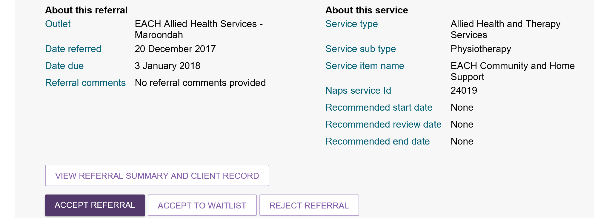

Then follow the same process as below.

All the below is after you have accepted the referral.

1. Go to the ‘Plans’ tab and expand ‘Assessment Details’

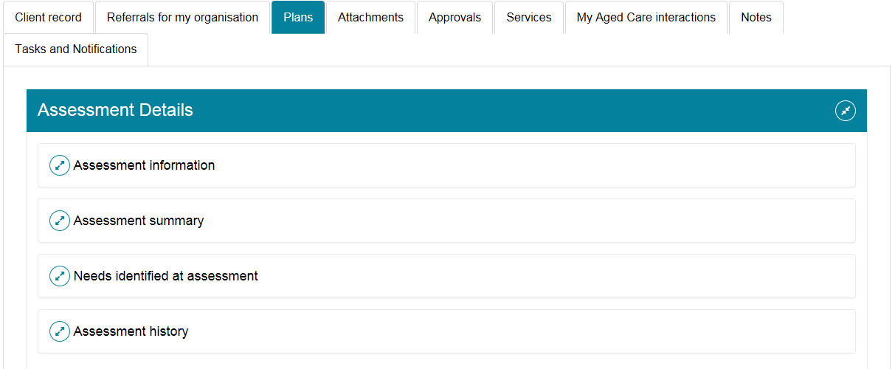

1. Expand ‘Assessment history’

This action will allow you to view all previously completed Assessments in My Aged Care

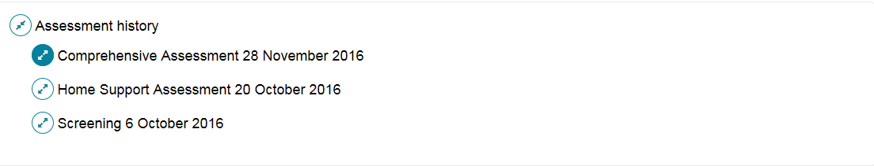

1. Expanding on Comprehensive Assessment will allow providers to view details of the ACAS assessment

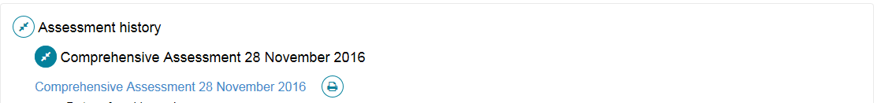

1. Expanding on Home Support Assessment will allow providers to view details of the RAS assessment

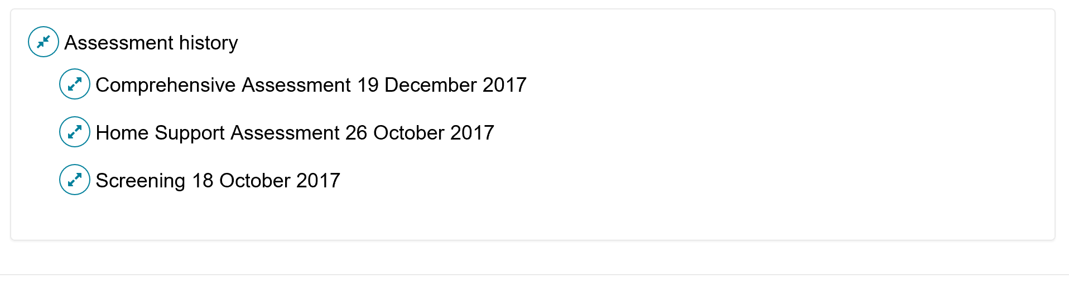

Only by expanding the assessment document does a print options become visible.

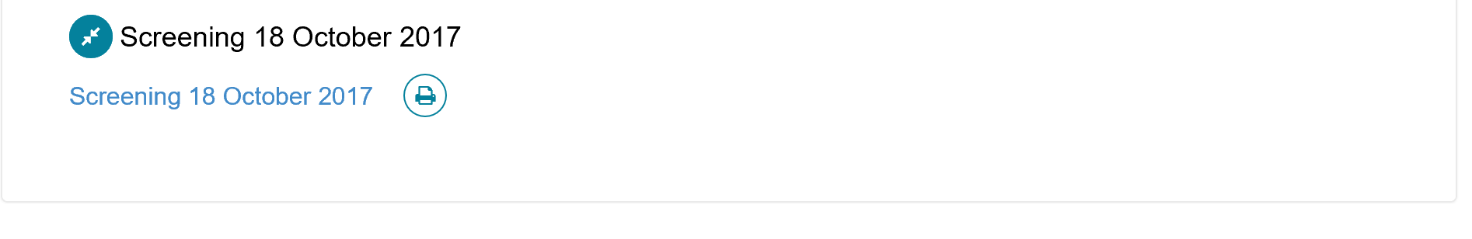

Click on the print symbol to view a PDF file of the assessment, choose to print or download/save it. NOTE: all assessments use the Nation Screening Assessment Form template and is a minimum of 50 pages long.



1. Click on the link to the Home Support Assessment to view the RAS assessment (NSAF)



This will allow providers to move around the domains of the NSAF tool and view information identified and recorded during RAS assessment. Selecting the links on the left hand side (e.g. Event Details, Function, Health conditions etc…) will expand the domain allow for more details to be viewed in the box on the right hand side:

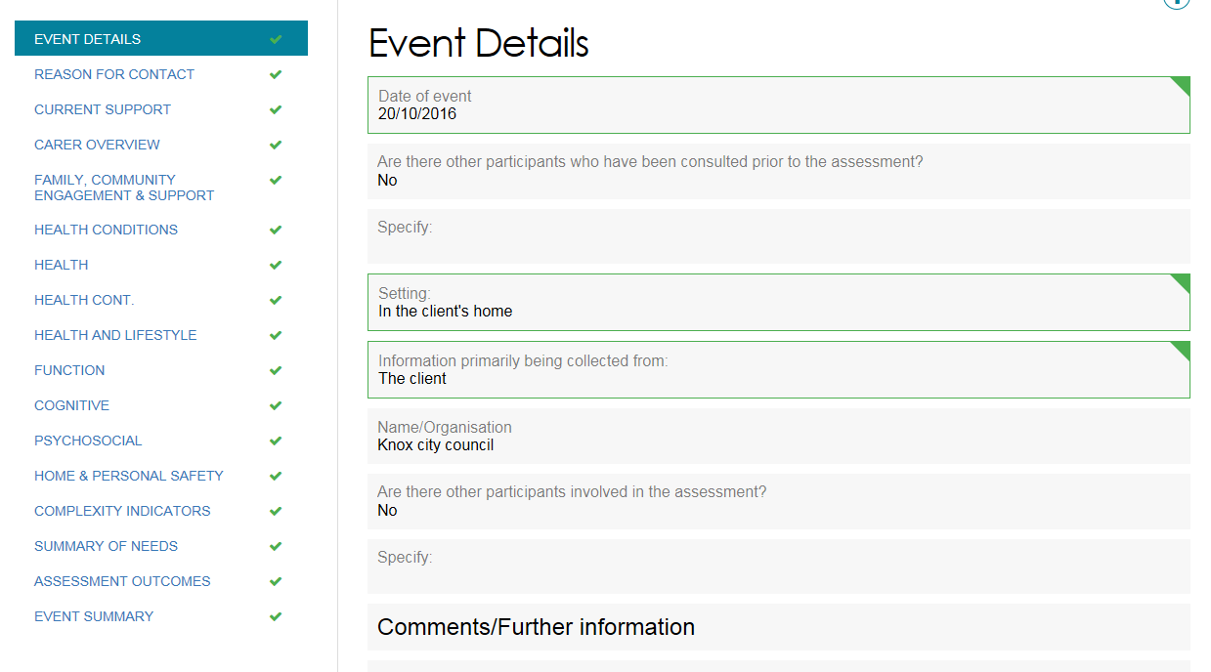

**Accessing a client’s Support plan**

Following system upgrades in July 2017, there are now several pathways to access a client’s Support plan.

1. In the ‘**Client Record**’ Tab

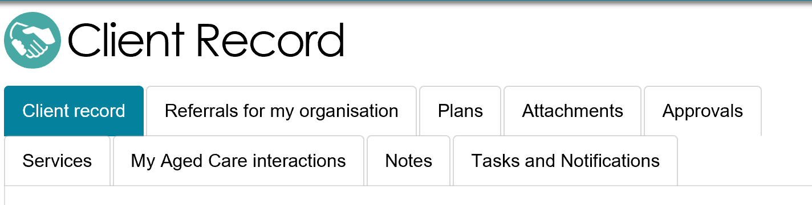

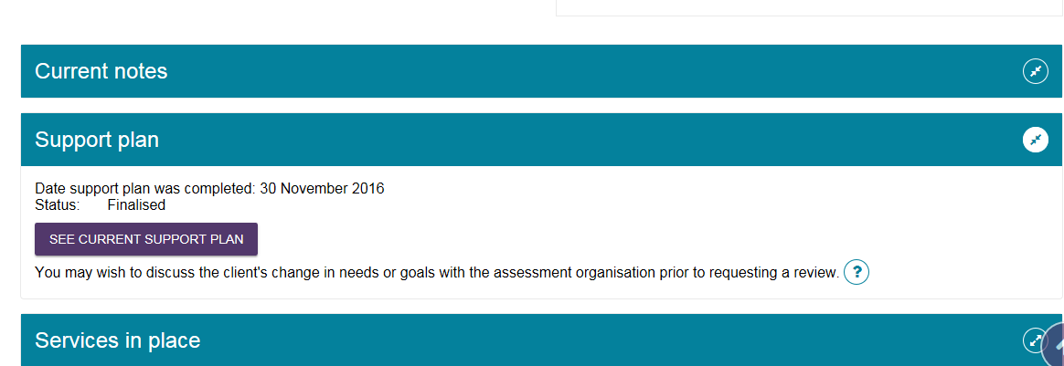

1. In the ‘**Plans**’ tab
   1. Click on ‘Plans history’

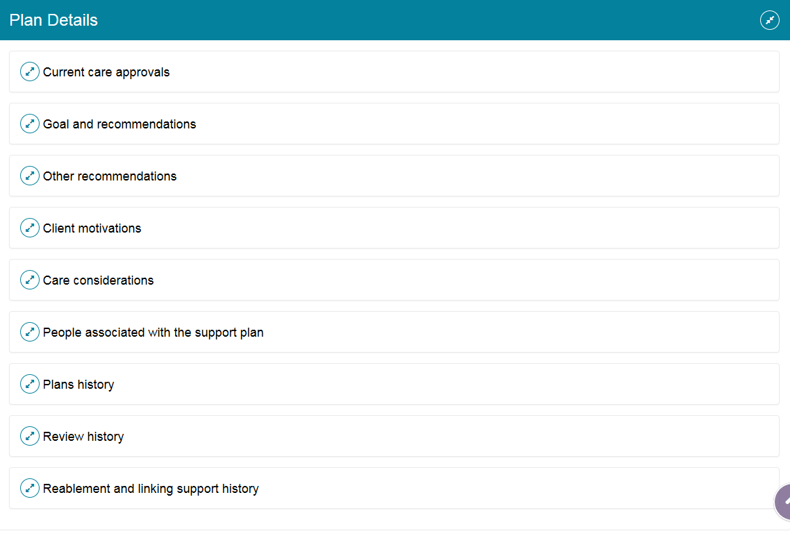

* 1. Select the link to the appropriate Support plan

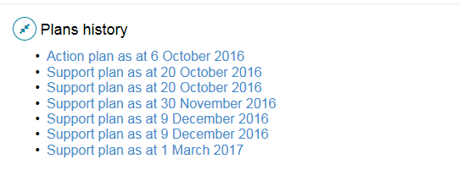

**Note: This is the end of possible options prior to accepting a referral.**

**Providers are encouraged to read “Notes” prior to accepting referrals as assessors use this to add extra information that may be relevant. e.g. sensitive information regarding assessor concerns, contact issues.**

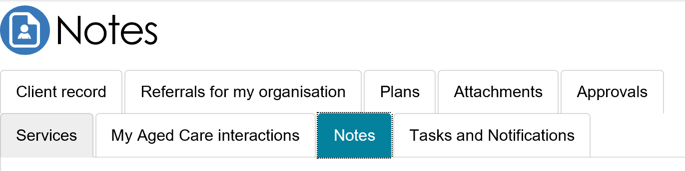

**Initiating a Support plan review via the Service provider portal**

1. Log into the Service provider portal and select the appropriate client record.
2. Select the Client record tab
3. Click on the ‘Request A Review’ button

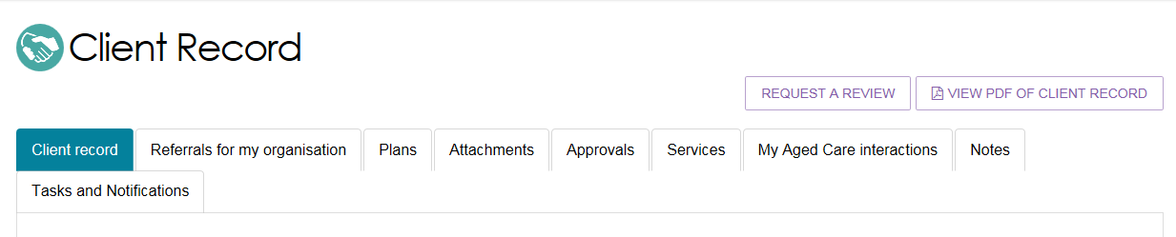

Requesting a Support plan review will send an electronic notification to the Assessment outlet that completed the most recent client assessment and support plan. A Support plan review request will appear in the ‘Review’ tab in the outlet’s My Aged Care Assessor portal.